Sell a Product

* When a seller lists a product it automatically goes to Active
* In the Faults tab – Missing parts(s) to be renamed to Missing Part(s)
* Once listed a product can you automatically make this disappear after 5 seconds

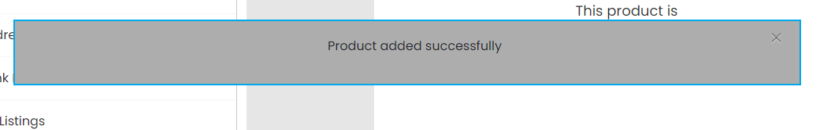

* Can draft and publish be in the bottom middle at all times

Frontend

* When selected “No Faults” it doesn’t appear when listed
* Brand new without tags is spelt wrong

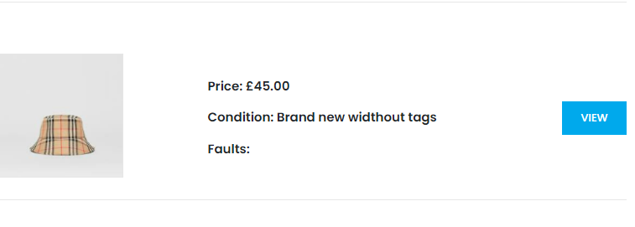

* When you click “View” can the product name look like this (Same font & Size)
* Can you sort the Faults section out? It looks a mess and is duplicated

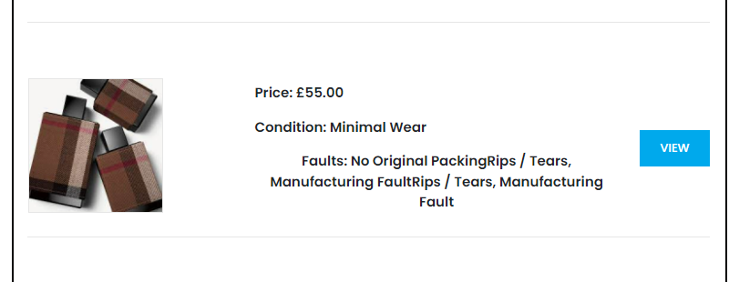

Admin

* When someone lists a Pre-Owned item, the price automatically changes to the cheapest price? I tried on the product with the SKU: 4 and every time I go to make the product active it goes to the cheapest price. Can you fix this?
* When admin tries to delete a sellers product, it doesn’t delete